**How to install CSSP Desktop**

Installing CSSP Desktop is a lot easier than previous CSSP tools once Charles LeBlanc Certificate is properly setup on your computer. The user only needs to load the web site: <https://csspdesktopinstall.azurewebsites.net/>. This will show a web page:

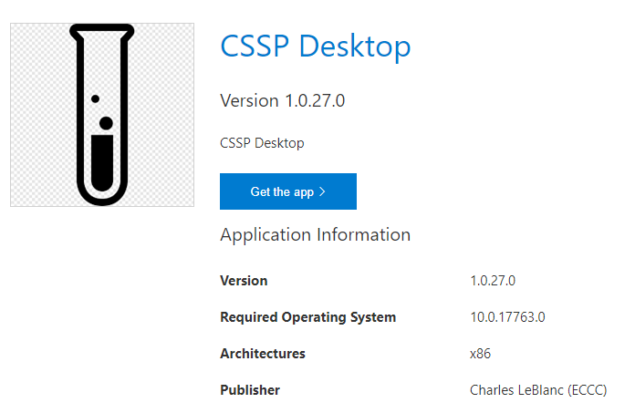

Clicking on the “Get the app >” will start the installation process.

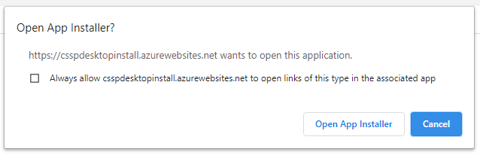

Clicking on “Open App Installer”

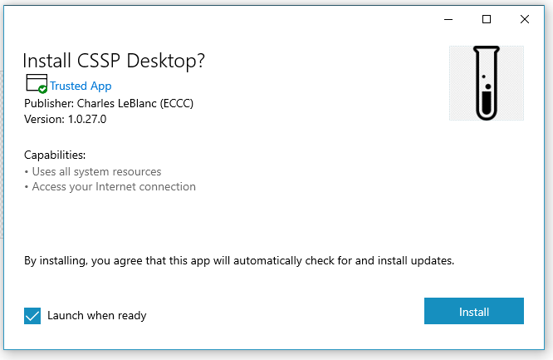

If you don’t see the text “Trusted App” then you must install Charles LeBlanc certificate.

Clicking on “Install” will download and install CSSPDesktop.

To keep the application icon on the bottom task bar just “right click” and select “pin to taskbar”.

Re-accessing the web site <https://csspdesktopinstall.azurewebsites.net/> will and following the same steps will give you:

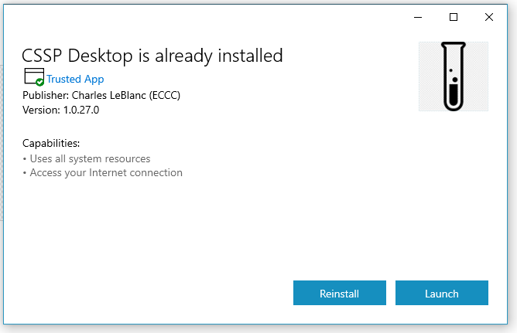

**Installing Updates CSSP Desktop**

Now that CSSP Desktop is installed, you will not have to worry about updates. Updates will be automatically done. When you run the CSSP Desktop application, it will check to see if updates are available (internet connection required). If updates are available then the next time CSSP Desktop runs it will automatically download and install the updates.

**Uninstalling CSSP Desktop**

Uninstalling CSSP Desktop is as easy as clicking on the Windows button or search area (bottom left of windows) and type CSSP Desktop. This should show the CSSP Desktop app in the best match list. From there you can right button on it and do a lot of stuff, including uninstall.

**Running CSSP Desktop**

Running CSSP Desktop is as easy as clicking on the icon located on the task bar or clicking on the Windows button or search area (bottom left of windows) and type CSSP Desktop. This should show the CSSP Desktop app in the best match list. From there you can directly press [ENTER] or click on CSSP Desktop.

**First Time Running CSSP Desktop**

The first time CSSP Desktop runs on your computer it might take some time as it will be setting everything up for it to properly work on your computer. This includes:

* Downloading and unzipping csspclient.zip to C:\CSSPDesktop\csspwebapis\csspclient\
* Downloading and unzipping csspwebapis.zip to C:\CSSPDesktop\csspwebapis\)
* Downloading and unzipping cssphelpdocs.zip to C:\CSSPDesktop\cssphelpdocs\)
* Creating an empty copy of C:\CSSPDesktop\cssphelpdocs\CSSPDBLocal.db
  + Is a local copy of the structure of CSSPDB database located on Azure
  + It is used to hold changed information which need to be synced with the Azure DB
  + It also permits the users to run CSSP Desktop without internet connection for a while and then sync the information back to Azure
* Creating an empty copy of C:\CSSPDesktop\cssphelpdocs\CSSPDBFilesManagement.db
  + Is used by CSSPWebAPIs to help manage and sync the local CSSP files (csspfiles) and Azure CSSP files (csspfiles)
* Creating an empty copy of C:\CSSPDesktop\cssphelpdocs\CSSPDBLogin.db
  + It is used to hold the required information to login without internet connection
  + It also stores all the user preferences for later uses
* You will be asked to Login using your CSSPWebTools credentials.
  + This is a one-time thing necessary for being able to login without internet connection

**How CSSP Desktop Works**

When installing and running CSSP Desktop for the first time, there are many things being setup on the user computer as explained in previous sections. This section will explain in more detail what each part of CSSP Desktop does.

Starting CSSP Desktop

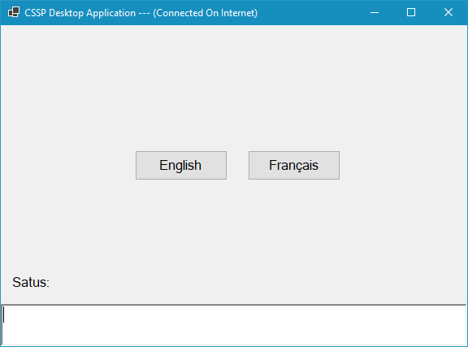

**Title bar**: Shows the name of the application and will indicate if the user has internet connection or not.

**Main Window**: Various things will appear on this main part. The image above shows the language selection page.

**Status bar**: Shows basic help and status of what the application is trying to do

**Detail status section**: The bottom section is where a log of the activities will appear as well as errors when they occur

The first page you will see when running CSSP Desktop is the language selection page. Clicking on a language will determine the language used for CSSP Desktop as well as the User Interface (discussed later).

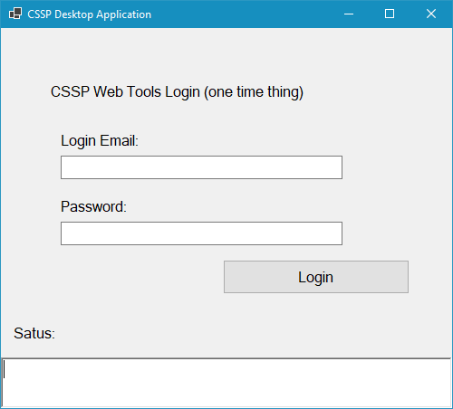

The login page is composed of:

**Login Box**: You need to provide the same Login Email used in the old CSSPWebTools

**Password**: You need to provide the same Password used in the old CSSPWebTools

**Login Button**: Click on the Login button to login.

Note: This is a one-time login thing. You need to be connected to the internet as your login information will be compared with the one used in CSSPWebTools.

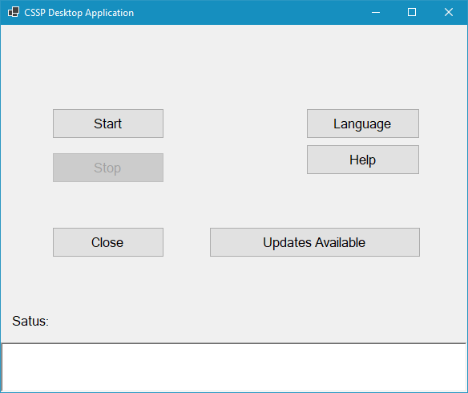

The central page is composed of:

**Start Button**: This button will start both a local CSSPWebAPIs and the web user interface (UI).

**Stop Button**: This button will close both the local CSSPWebAPIs and the web user interface if opened

**Close**: This button will close the CSSP Desktop application

**Language**: This button will reopen the first language page so you can select the preferred language to use

**Help**: This button opens a detailed help with many how to and SOPs

**Updates Available**: This button will send you to another page to help you update the web component of the CSSP Desktop (CSSPWebAPIs and web UI). Everytime you run CSSP Desktop and you are connected to the internet, the application will check on Azure to see if new updates are available for the web component of the application. If no update is available then the button will be disabled.

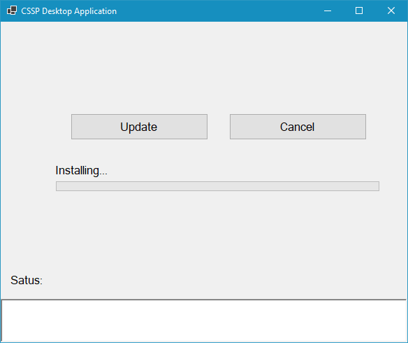

The update page is composed of:

**Update Button**: This button will start installing the updates on your local machine

**Cancel**: This button cancels this page and sends you back to your central page

**Installing Progress Bar**: Will track the progress of the installation of the updates

**Detail Status Section**: Will show details of what is being done in the background. If for whatever reason they are errors during the update, this will also be the place to show them.